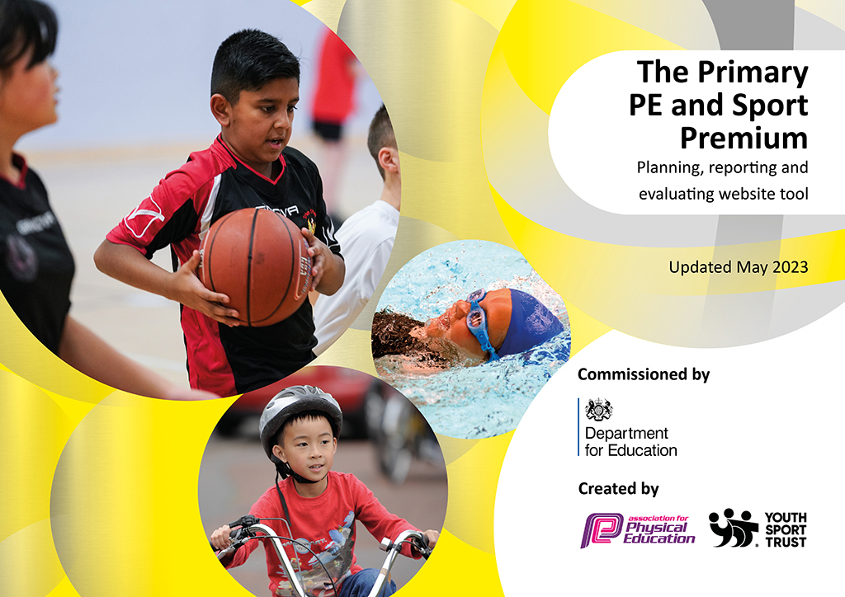
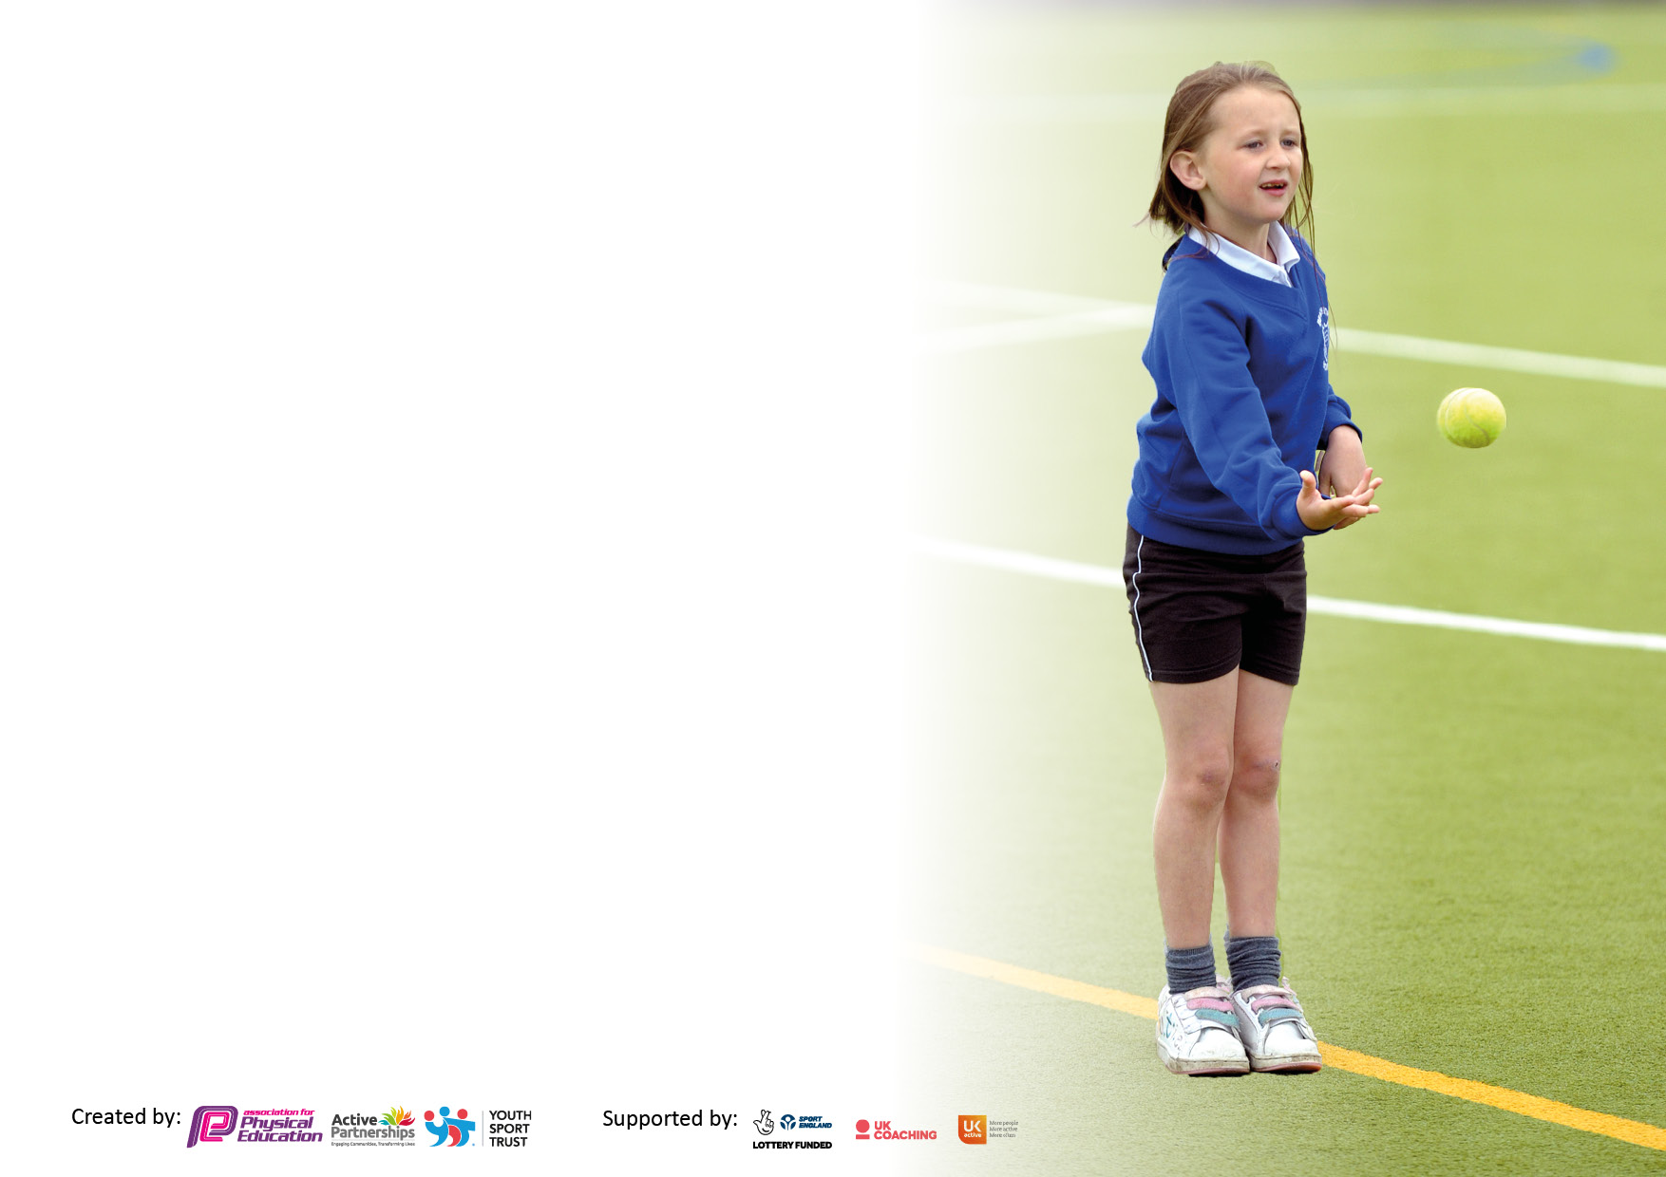

It is important that your grant is used effectively and based on school need. The Education Inspection Framework makes clear there will be a focus on ‘whether leaders and those responsible for governors all understand their respective roles and perform these in a way that enhances the effectiveness of the school’.

Under the Quality of Education Ofsted inspectors consider:
Intent - Curriculum design, coverage and appropriateness
Implementation - Curriculum delivery, Teaching (pedagogy) and Assessment
Impact - Attainment and progress

To assist schools with common transferable language this template has been developed to utilise the same three headings which should make your plans easily transferable between working documents.

Schools must use the funding to make additional and sustainable improvements to the quality of Physical Education, School Sport and Physical Activity (PESSPA) they offer. This means that you should use the Primary PE and sport premium to:

- Develop or add to the PESSPA activities that your school already offer
- Build capacity and capability within the school to ensure that improvements made now will benefit pupils joining the school in future years
- The Primary PE and sport premium should not be used to fund capital spend projects; the school’s budget should fund these.

Please visit gov.uk for the revised DfE guidance including the5keyindicatorsacrosswhichschoolsshoulddemonstrate an improvement. This document will helpyoutoreviewyourprovisionandtoreportyourspend.DfEencouragesschools to use this template as an effective way of meeting the reporting requirements of the Primary PE and Sport Premium.

We recommend you start by reflecting on the impact of current provision and reviewing the previous spend.

Schools are required to publish details of how they spend this funding, including any under-spend from 2021/2022, as well as on the impact it has on pupils’ PE and sport participation and attainment. The funding should be spent by 31st July but the DfE has stated that there will be no clawback of any unspent money so this can be carried forward into 2023/24.

We recommend regularly updating the table and publishing it on your website throughout the year. This evidences your ongoing self-evaluation of how you are using the funding to secure maximum, sustainable impact. Final copy must be posted on your website by the end of the academic year and no later than the 31st July 2023. To see an example of how to complete the table please click HERE.

Details with regard to funding
Please complete the table below.

Total amount carried over from 2021/22 | £0
Total amount allocated for 2021/22 | £19630
How much (if any) do you intend to carry over from this total fund into 2022/23? | £0
Total amount allocated for 2022/23 | £19630
Total amount of funding for 2022/23. Ideally should be spent and reported on by 31st July 2023. | £19630
Swimming Data
Please report on your Swimming Data below.

Meeting national curriculum requirements for swimming and water safety.

N.B. Complete this section to your best ability. For example you might have practised safe self-rescue techniques on dry land which you can then transfer to the pool when school swimming restarts.
Due to exceptional circumstances priority should be given to ensuring that pupils can perform safe self rescue even if they do not fully meet the first two requirements of the NC programme of study
What percentage of your current Year 6 cohort swim competently, confidently and proficiently over a distance of at least 25 metres?  N.B. Even though your pupils may swim in another year please report on their attainment on leaving primary school at the end of the summer term 2023.  Please see note above | 60%
What percentage of your current Year 6 cohort use a range of strokes effectively [for example, front crawl, backstroke and breaststroke]?  Please see note above | 60%
What percentage of your current Year 6 cohort perform safe self-rescue in different water-based situations? | 81.67%
Schools can choose to use the Primary PE and sport premium to provide additional provision for swimming but this must be for activity over and above the national curriculum requirements. Have you used it in this way? | No

Action Plan and Budget Tracking
Capture your intended annual spend against the 5 key indicators. Clarify the success criteria and evidence of impact that you intend to measure to evaluate for pupils today and for the future.

Academic Year: 2022/23 | Total fund allocated: | Date Updated:
Key indicator 1: The engagement of all pupils in regular physical activity – Chief Medical Officers guidelines recommend that primary school pupils undertake at least 30 minutes of physical activity a day in school |  |  |  | Percentage of total allocation:
 |  |  |  | 46.8%
Intent | Implementation |  | Impact
Your school focus should be clear what you want the pupils to know and be able to do and about  what they need to learn and to  consolidate through practice: | Make sure your actions to achieve are linked to your intentions: | Funding allocated: | Evidence of impact: what do pupils now know and what can they now do? What has changed?: | Sustainability and suggested next steps:
Support and involve the least active children by providing targeted activities, afterschool clubs and encourage participation in the Sandwell Games.  Introduce new sports (including a variety of dance) and other activities to inspire pupils to participate in sport and physical activities.  Playground Activator programme  New equipment to be purchased to support break time and lunchtime activities in Key Stage 1 & 2, engaging children in physical activity  Training of Young PE leaders – to help run and organise lunch time activities and assist during any themed days or whole school house competitions.  Children to be more active in a range of lessons – CPD for staff members throughout the year which will provide children with a high quality lessons in a range of activities.  Themed Days – e.g. Invite Alice Dearing (ex St. Hubert’s pupil) and other professional athletes into school to host inspirational talks.  Children understand why walking/cycling is a healthy option  Children understand how to stay safe on bikes and when walking.  Assessment of the pupils who attend afterschool clubs will be analysed. Any pupils found to attend less than 1 club per year will be reviewed and based on the needs of the child will be offered the opportunity to attend afterschool clubs to receive an additional 1 hour of physical activity through extra-curricular provision. | Targeted specific children throughout school for Sandwell Games events and participation in afterschool clubs.  RB Gym and Premier Education afterschool clubs and CPD sessions.  With children spending up to 20% of their school day on the playground, we need to make better use of this time and help all children engage in physical activity.  Provide equipment/resources to introduce new sports into the KS1/KS2 playground, to improve delivery of existing ones and to support wide range of lunchtime and leisure sports activities.  Training of 5 Play and Sport Leaders through Premier Education. Purchase badges, Equipment and Awards for children.  CPD for staff – bring in trained coaches (RB Gym).  Book themed days for children to explore new activities – bring in trained coaches and professional athletes – CPD for staff. Play leaders to help organise days.  Year 5 & 6 - bike ability.  Year R – Balance ability. | £500  £2700  £3,000  £3000 | Max 20 children per afterschool club targeted.  Throughout the academic year 2022/23 227 different children attended a sports afterschool club.  Afterschool clubs run throughout the year include:  KS1:  - Irish dancing  - Football  - Street dance  - Gymnastics  - Multi sports  - Athletics  KS2:  - Tchoukball  - Irish dancing  - Basketball  - Netball  - Football  - Gymnastics  - Multi sports  - Dodgeball  Athletics | - More equipment will be ordered specifically for lunch times which the play leaders will help to monitor.  - Sign up for ‘Active Sports’ so that all children’s physical development/ fitness can be more accurately monitored and accessed throughout each year and through the school.  - Buy additional storage for lunchtime equipment.  - Young PE leaders programme was not successful. Have not renewed this programme with Premier Education for next academic year but will look to invest in the WBA Foundation programme instead.  Organise more themed days throughout the year to provide role models for the pupils.
Key indicator 2: The profile of PESSPA being raised across the school as a tool for whole school improvement |  |  |  | Percentage of total allocation:
 |  |  |  | .2%
Intent | Implementation |  | Impact
Your school focus should be clear what you want the pupils to know and be able to do and about  what they need to learn and to  consolidate through practice: | Make sure your actions to achieve are linked to your intentions: | Funding allocated: | Evidence of impact: what do pupils now know and what can they now do? What has changed?: | Sustainability and suggested next steps:
Promote school’s sporting achievements to a wide audience – Seesaw and PE newsletters for parents and end of term awards assembly.  PE subject leader will regularly update the PE curriculum to bring it in line with the whole school focus, creating objectives for teachers to use in their planning. Long term curriculum plan to be made in line with hall timetable (PE hub).  Take part in Sandwell Primary School Competitions and use this as an indicator for improvement and achievement.  Role models -local sporting personalities so pupils can identify with success and aspire to be a local sporting hero. | Sports board to show whole school competition results. Parents to be informed of activities and achievements in newsletter.  Strategic analysis of planning – against schools learning ladders. Analysis of assessment systems linked to date on DC Pro.  Sign up to Sandwell Primary School Competitions.  Invite a range of local/UK personalities into school to host inspirational talks/activities. | £0  £0  £40  £0 | - Behaviour and achievement, behaviour and attendance.  - PE and physical activity have a high profile throughout the school.  - Continued progression of all pupils during the curriculum PE lessons.  - Pupil voice shows that PE is a highly enjoyed and valued lesson for all pupils (including pupil premium, SEND and EAL pupils).  - Interhouse competition have occurred one every term and been well received by the children who have enjoyed a healthy level of competition.  - Sports/play leaders set a positive example for other pupils (especially with the girl play leaders).  - Successful Sports Days held – all pupils able to attend and participate with many bring their parents.  - Nearly all Year groups have been to at least one Sandwell Games competition competing in a range of physical activity.  - Through the use of the 6C’s the children are provided with opportunities to learn important skills such as respect, teamwork and self-discipline.  - World Athletics Day and GB athlete in school for whole school assembly provided children with additional opportunities and inspired children. | - Review and update whole school PE policy.  - Use PE conference to review, evaluate and plan for upcoming academic year.  - Continue to monitor staff who have received CPD (Are they more confident and better equipped to lead plan and lead PE lessons?).  - Monitor the use of The PE Hub. Are we still getting the coverage we want and need?  - Introduce new Year 5 PE/play leaders (must include a mix of genders).  - Identify the impact that PE and PE competitions can have on academic achievement.

Key indicator 3: Increased confidence, knowledge and skills of all staff in teaching PE and sport |  |  |  | Percentage of total allocation:
 |  |  |  | 43.3%
Intent | Implementation |  | Impact
Your school focus should be clear | Make sure your actions to | Funding | Evidence of impact: what do | Sustainability and suggested
what you want the pupils to know | achieve are linked to your | allocated: | pupils now know and what | next steps:
and be able to do and about | intentions: |  | can they now do? What has
what they need to learn and to |  |  | changed?:
consolidate through practice:
Provide staff with professional development, mentoring, training and resources to help them teach PE and sport in the most effective way possible.  Identify children who do not meet the Early Learning Goals. These children will be specifically targeted in Year 1 and provided with opportunities to develop physically.  Sports coach employed 2 days a week and after school to engage different sections of pupils in physical activity.  Staff CPD (using RB Gym) to improve the teaching and understanding of staff on the progressions and differentiation of a range of sports, thus leading to improved progress and achievement of all pupils. Work with Lunchtime staff on importance of being active at lunchtimes  Dance Desk (holistic PE approach) subscription and curriculum support  Scheme of work for Pre School – follow up – subject leader to analysis the new scheme ordered for Pre-School and ensured that it has been embedded successfully.  Subscription to PE hub | Teachers receiving CPD will complete weekly impact report via RB Gym Performance Development Booklet.  Schedule in place to ensure ultimate efficiency of time – CPD for staff. (RB Gym)  Staff to be coached alongside sport coaches from RB Gym at how to progress children in their class. CPD to be offered for sports/activities which staff are least confident teaching. Coaches to ensure that teachers are provided with ideas and progressions for individual children within classes (support and challenge).  Provide subscription to Coordinator network including CPD. National & professional support memberships.  Improve teaching and provide new ideas for the curriculum.  Improve confidence of teachers to deliver high quality PE with up-to date pedagogy.  Ensure that scheme is suitable for the Pre-School staff and their needs to ensure that children are receiving high quality education.  Staff to be able to use same planning for the whole year and start to understand their units, following long term plan. Teachers to use OLSH Medium term plans to write up PE hub planning in line with other school planning documents. | £7000  £0  £900  £0  £600 | - Improved staff confidence and knowledge to plana and teach PE lessons.  - More confident and competent staff evidenced through lesson observation and staff voice survey.  - Increased pupil participation in competitive activities and festivals.  - A more inclusive PE curriculum.  - Staff have improved understanding of how to differentiate for the needs of their class for a range of physical activities. | - Continue to review and monitor PE lessons for effective and high-quality teaching.  - Allocate staff for CPD based on their responses to the staff survey.  - Monitor teaching of SEND pupils.  - Review the use of The PE Hub.
Key indicator 4: Broader experience of a range of sports and activities offered to all pupils |  |  |  | Percentage of total allocation:
Intent | Implementation |  | Impact
Your school focus should be clear | Make sure your actions to | Funding | Evidence of impact: what do | Sustainability and suggested
what you want the pupils to know | achieve are linked to your | allocated: | pupils now know and what | next steps:
and be able to do and about | intentions: |  | can they now do? What has
what they need to learn and to |  |  | changed?:
consolidate through practice:
To ensure all existing swimmers increase their attainment by 10 metres thus increasing their confidence in water. All remaining non swimmers achieve 25 meters thus meeting the statutory requirements of the national curriculum for PE. All pupils can perform safe self-rescue over a varied distance so they are confident and safe in water. | Additional pool hire and swimming teachers are purchased for the whole year to ensure children reach their maximum potential in swimming. To utilise the coach based at the swimming pool to work alongside teachers. | Curriculum budget | - Increased pupil participation.  - Improved quality and effectiveness of teaching.  - Enhanced extra-curricular activities.  - Improved behaviour.  - Increased opportunities and awareness of pupil/parent/carers within the local community.  - Improved physical and mental health.  - Improved mental understanding of a range of physical activities.  Improved transferable life skills (6C’s) including (character, collaboration and communication. | - Worked closely with our chosen CPD and afterschool club providers to ensure they understand our vision for PE and ensure they are meeting our expectations.  - Further increase the number of wider opportunities which have been made available for all Year groups.  - Increase the number of SEND competitions/festivals attended.  Increase girls only participation to competitions and festivals.

Key indicator 5: Increased participation in competitive sport |  |  |  | Percentage of total allocation:
 |  |  |  | 9.6 %
Intent | Implementation |  | Impact
Your school focus should be clear | Make sure your actions to | Funding | Evidence of impact: what do | Sustainability and suggested
what you want the pupils to know | achieve are linked to your | allocated: | pupils now know and what | next steps:
and be able to do and about | intentions: |  | can they now do? What has
what they need to learn and to |  |  | changed?:
consolidate through practice:
Inter and intra competitions to be carried out every half term.  Sandwell Primary School Competition  Whole school Sports Day. | PE lead to organise and launch house competitions to be completed in PE lessons and results recorded and shared through parent newsletters, whole school assemblies and on the PE display board.  Classes have been signed up to a number of the Sandwell Primary School Competitions to provide opportunities to compete against other schools. | £0  £0  £1,890 (8 days) | - Every class participated in interschool competitions.  - Sports Day set up, participated in and enjoyed by all pupils.  - Results of competitions have been shared in school newsletters.  - Afterschool club registers. | - Review afterschool club and school competition data to identify children for further opportunities.  - Continue to attend AFPE meetings to ensure our PE provision is in line with national standards.  - Further widen opportunities to participate in competitive physical activities.  - Increase number of interhouse competitions.  - Create an aware to be shared during merit assemblies (Sports star of the week).  Staff attending during the day (supply cover)

Signed off by
Head Teacher: | Ms O. O’Beirne
Date: | 12.07.2023
Subject Leader: | Mr J. Jay
Date: | 11.07.2023
Governor:
Date: | 12.07.2023

